December 27, 2007

TO:
Washington State House & Senate
Washington State Supreme Court
Washington State Attorney General Office
Washington State Secretary of State

Washington State Governor
Washington State Senator Murray
Washington State Senator Cantwell
Washington State Representative Reichert
Association of Washington Cities
Freedom Legal Groups
Freedom Foundations
Property Right Groups
King County Council
King County Ag
King County DDES
Media
Friends

You may scroll the topic headings, graphs & underscore below in a few minutes to connect more dots of government tyranny & taking

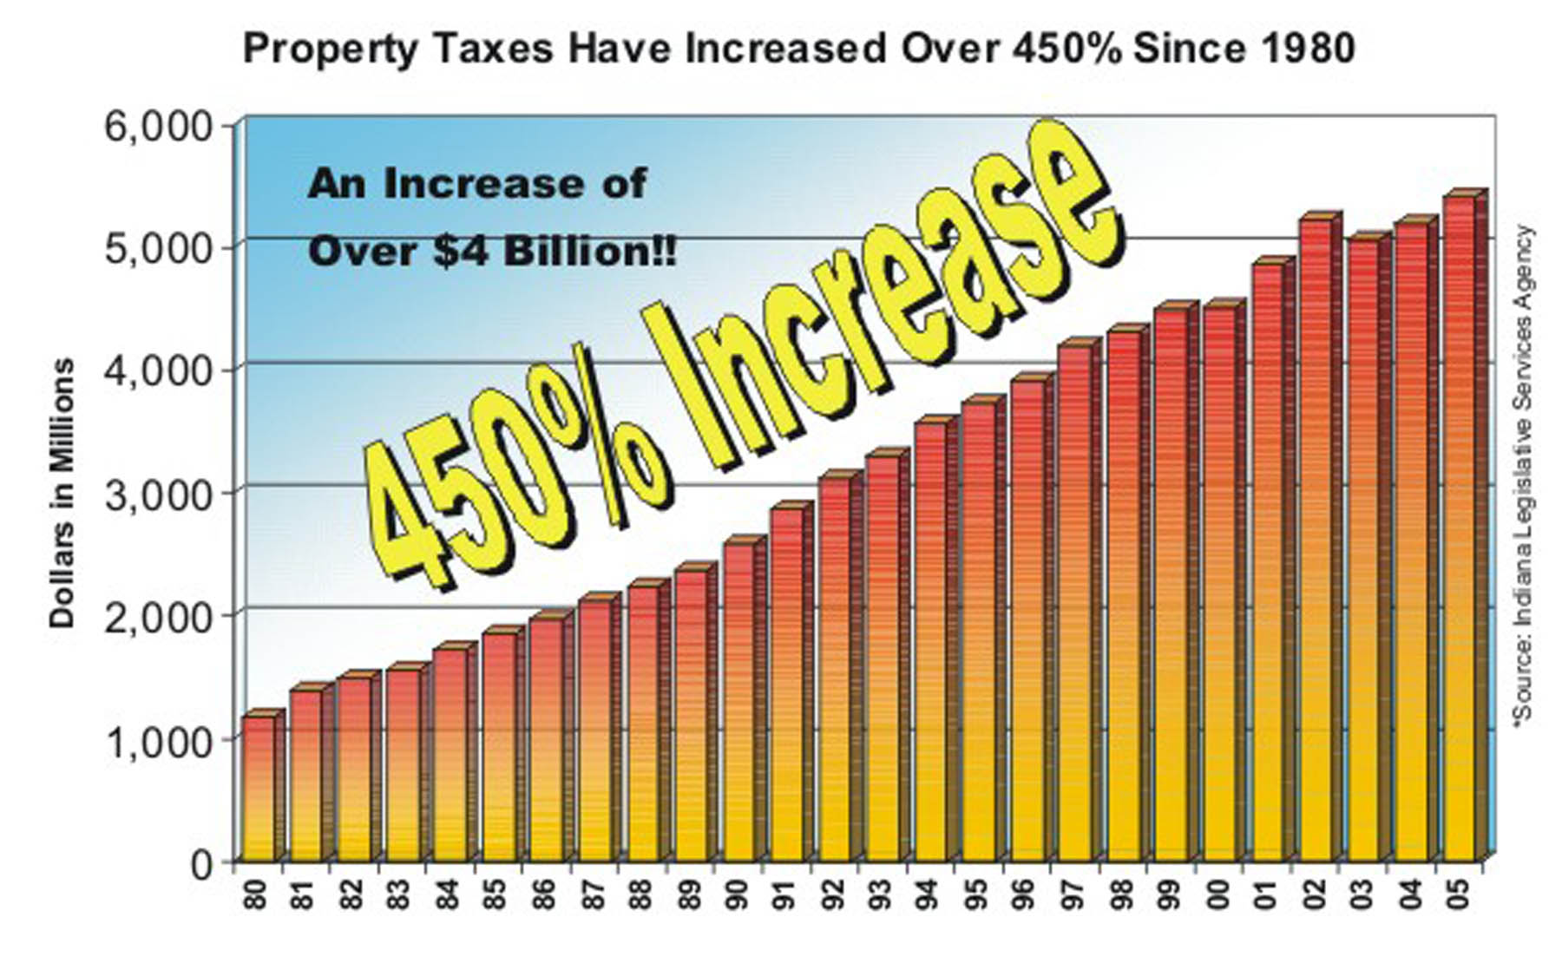
http://www.advanceamerica.com/rpt/pdf/RPT%20PLAN.pdf
http://www.repealpropertytaxes.com/stats.htm

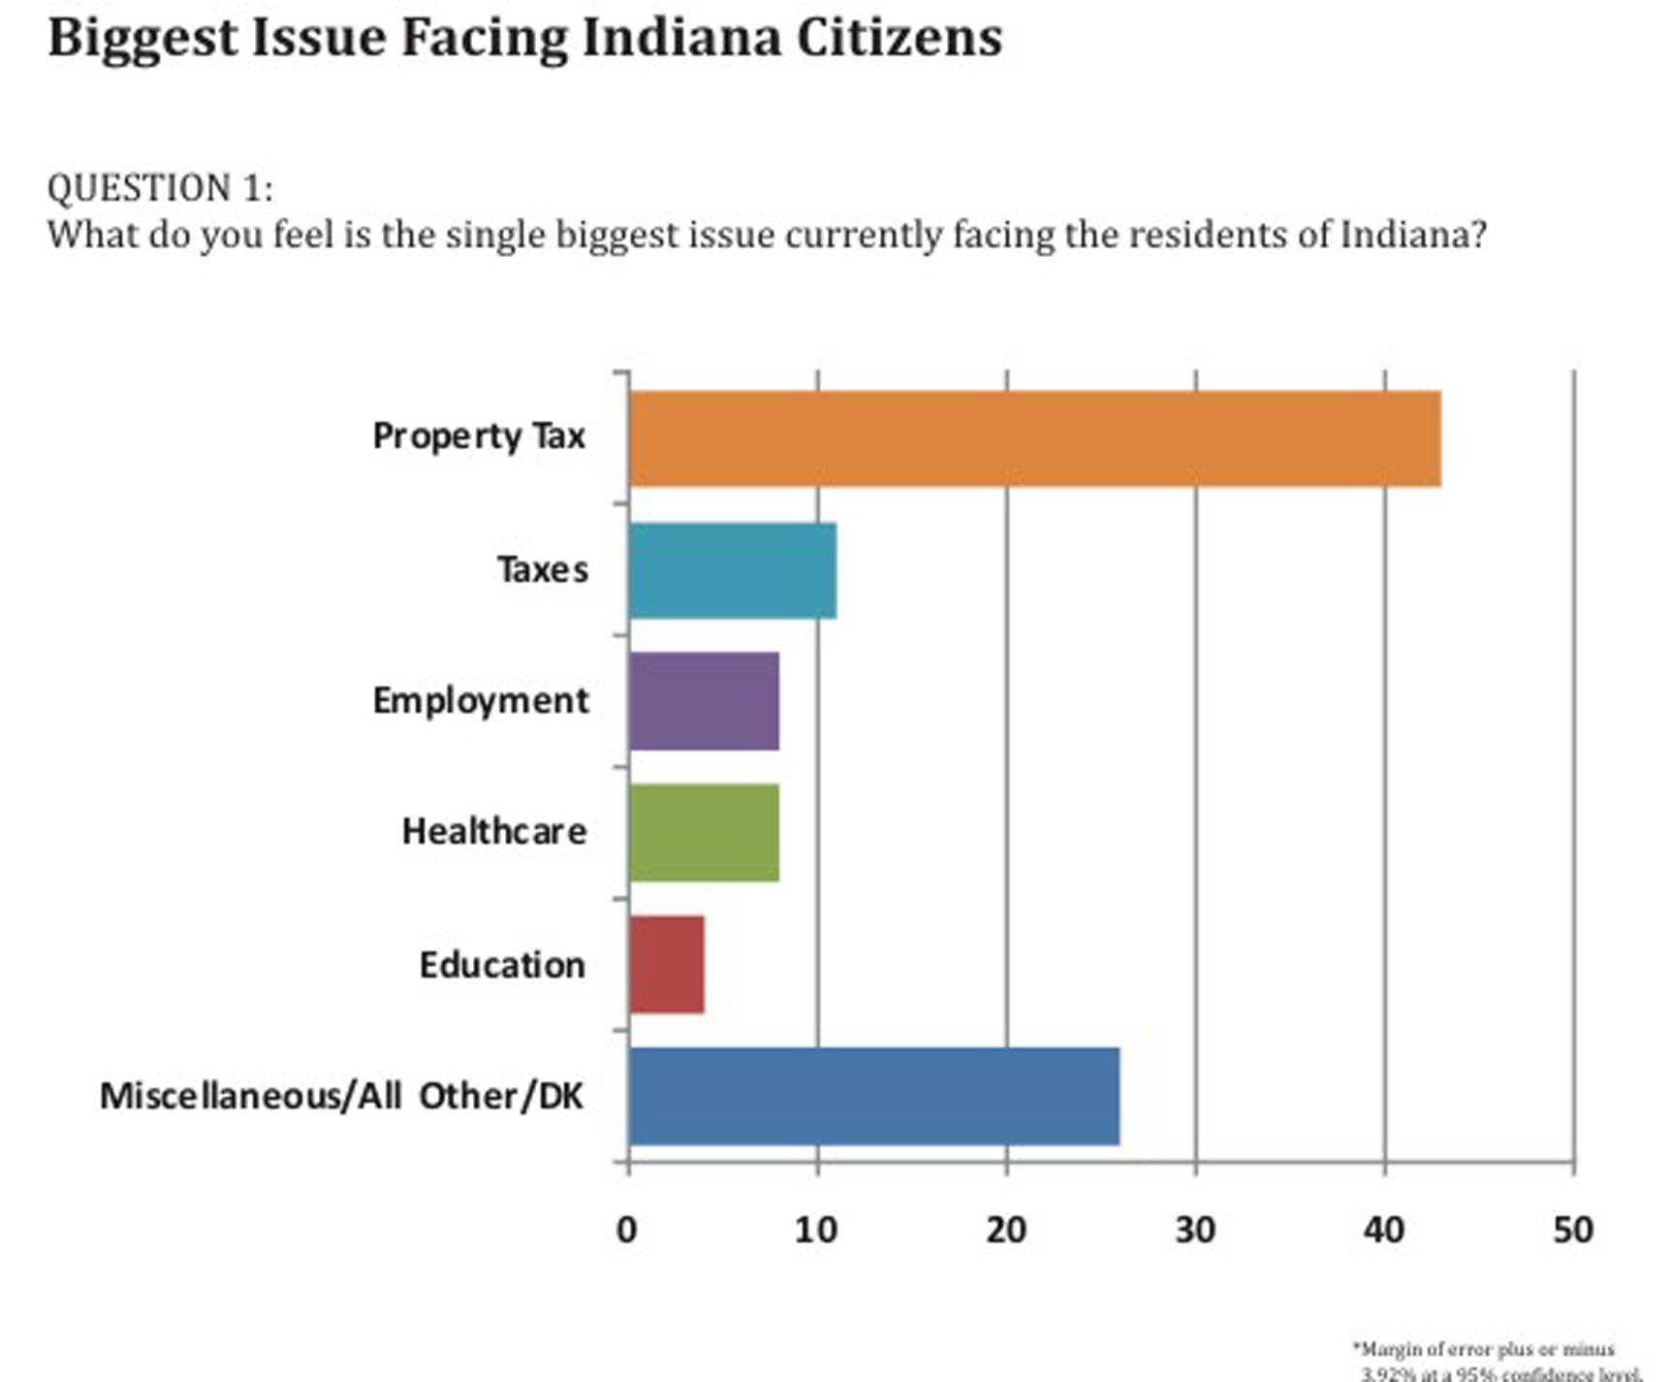
http://www.repealpropertytaxes.com/RPTPoll/Q1.htm

1. If The United States Constitution is the Supreme Law of the Land....
- Why are higher courts ignoring prior precedent cases, constitutional law & inalienable rights re. private property?
- Why are the legislatures & executive offices ignoring founding laws & trashing basic rights re. private property?
- Why are basic Constitutional laws, which are clear to us, not clear to the courts, legislature or administration?
- Why are not the courts, legislature & administration unanimous in protecting property rights cases?
- Why are all of our constitutional & inalienable rights being taken?
- Why does government create & enforce their own rules while ignoring every basic God given, natural, common & constitutional law in the land? e.g. green laws, alternative energy laws, social programs, worthless paper money, taxes, state Ed, et al.

2. We the people are sovereign citizens in sovereign states
- The Framers understood there is no higher power than an independent free man or women, next to God.
- No judge, jury, legislature, executive, UN, elected or unelected body can usurp individual sovereignty, legitimately
- Not even the constitution can usurp individual natural and inalienable rights, without force
- "Citizens possess rights; these rights cannot be converted to privileges by government or anyone"
- The only individuals who would not have these rights & would therefore be liable to regulation by government are NONRESIDENT ALIENS doing business and working within the United States ... "
- http://www.the7thfire.com
- Anything taken by force from a sovereign citizen goes against all laws of the land and of God, its called stealing
- The Framers knew this, they suffered & revolted from 100 years of tyrannical tax taking of King George III
- Why would they create forced tax tyranny in a constitution invoking what they loathed?

3. The following servants in WA State House/Senate place their career above their oath of office, laws of the land & sovereignty of citizens.
- http://www.permanent-offense.org/scarletletter.pdf
- You can add King County & Pierce County & most Puget Sound councils & the code enforcement departments to this list
- Print this list out and tape it where you can memorize the names and background
- These elected representatives and senators have voted to continue the embezzlement, larceny & extortion of private property against the laws of the land.
- This is in addition to the Washington Supreme Court subverting an initiative by WA citizens overwhelming voting to limit property taxes.
- This is in addition to Washington State property taxes being unconstitutional and unworkable, as you will read below.
- This is in addition to the governor and her army having to be pressured to over ride the high court injustice
- Still the takers were not quite able to set the clock of taking completely back to where We The People put it.
- We must understand that there is no government employee left that is "good"
- The evil of progressive relativism, taking & ignorance reign supreme
- The good cannot undue the exponential toll of taking until We The People Are Totally Free Again

"I do solemnly swear (or affirm) that I will support the Constitution of the United States and the Constitution and laws of the state of Washington, and that I will faithfully discharge the duties of the office of (name of office) to the best of my ability."

4. Here is how 5 of the 9 Judges on the Washington State Supreme Court Violated the United States Constitution AGAIN.
- "But today, because of a 5-4 ruling by the State Supreme Court saying
voters "didn't understand" and were "misled" into approving I-747,
taxpayers now face the nightmare scenario…We're in for absolute chaos. For six years, local governments (counties, cities, ports, library districts, fire districts, cemetery districts, parks districts, etc.) have been held to a 1% levy each year. Their ruling today says I-747 no longer exists, and so local governments now suddenly have the unused taxing authority that they've accumulated over the past six years (5% per year -- 6% instead of 1%). That means that each local government now has the power to jack up property taxes 30% this fall without a vote of the people (I-747 required voter approval -- now that I-747 is overturned, voter approval is no longer be required). Every local government knows that if they don't take advantage of the situation and unilaterally increase taxes using this unused taxing authority, the Legislature in 2008 might take that authority away. They'll have to "use it or lose it." Don't believe a local government would ever raise property taxes in a single year? In 2002, the Port of Seattle jacked up their property tax levy an astonishing 37% using unused taxing authority - they got heat for it but they never repealed it." Tim Eyman
.
- " The 4 justices (of the 9) who wrote the minority opinion said it well: "No
reasonable argument can be sustained that voters were in any way misled or
confused by the effect of I-747, ……which expressly and was specifically aimed at lowering the tax growth to one percent. The majority seems to suggest that the voters are unable to think or read for themselves, when in fact our democratic process is based on the assumption that voters do in fact read and understand the impact of their votes." Tim Eyman

5. Here is a must watch video by Bill Styring, Ph.D, Economics, an expert on Indiana's property tax system.
- He eloquently describes the problem, history & why property taxes must be totally repealed.
- "Not only are they applied unconstitutionally, BUT THEY DONT WORK "
- http://stopindiana.com/default.aspx
- Indiana Taxpayers' Declaration of Rights - http://stopindiana.com/Documents/Taxpayerbillofrights.pdf

6. Here is an excellent article on why property taxes are unconstitutional (Must Read)
- Property tax assessed on appraised value is totally unconstitutional.
- http://taxprof.typepad.com/taxprof_blog/2005/11/texas_supreme_c.html

7. Here is an excellent video on the Indiana's property tax repeal movement supported by their Governor
- http://www.advanceamerica.com/rpt/

8. Here is a national effort to stop all property taxes by Texas Representative Ron Paul & 2008 Presidential Candidate
- http://www.stoptax.org/

9. Texas Supreme Court Rules Property Tax Unconstitutional
- http://www.jail4judges.org/JNJ_Library/2005/2005-11-23.html

10. New Hampshire Superior Court judge rules statewide property tax unconstitutional
- http://www.concordmonitor.com/apps/pbcs.dll/article?AID=/20051025/REPOSITORY/510250308/1001/NEWS01

11. Pennsylvania judge declares Pennsylvania Property Tax Assessments Unconstitutional
- http://www.pittsburghhomesdaily.com/2007/06/06/pennsylvania-property-tax-assessments-unconstitutional/

12. Indiana General Assembly Bi-partisan group files bills making property taxes unconstitutional
- http://www.in.gov/legislative/senate_republicans/newsroom/1-17-07.htm
- http://stopindiana.com/default.aspx
- http://www.indianavotersleague.org/questions/
- "Just government exists to protect life, liberty, and property and promote the general welfare. Government acts unjustly when its tax policy begins to diminish life, limit liberty, seize property and spread discontent among the people. Such a government is immoral. As we weigh our options, moral criteria must supersede habits of convenience, custom, and special interest. There is reason to question the morality of Indiana's tax policy. Until these are publicly addressed the government of Indiana lacks moral legitimacy."
- http://hoosiersforfairtaxation.blogspot.com/

13. Washington State property tax is a regressive tax
- http://www.historylink.org/essays/output.cfm?file_id=5726

14. The Un-American Unconstitutional Property Tax
- http://www.geocities.com/northstarzone/PTAX.html

15. The Coming Property Tax Battle
- http://recenter.tamu.edu/TGrande/vol9-1/1544.html

16. The States in the Chart Below are Committing the Highest Crimes Against Private Property Owners
- i.e., constitutional fraud, embezzlement, larceny, misfeasance, malfeasance and treason.

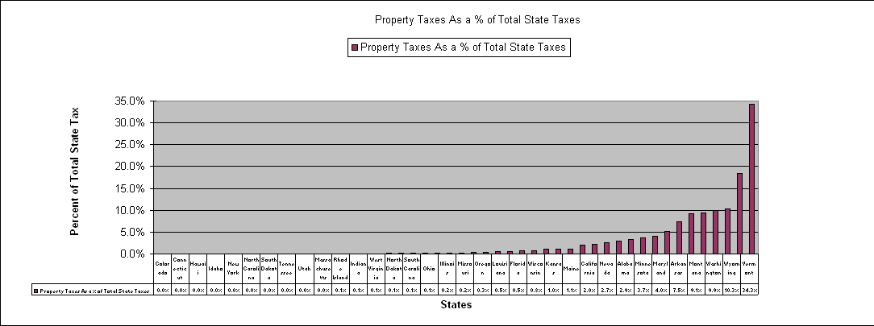
Above chart compiled and graphed from data in www.taxfoundation.org by J. Venrick
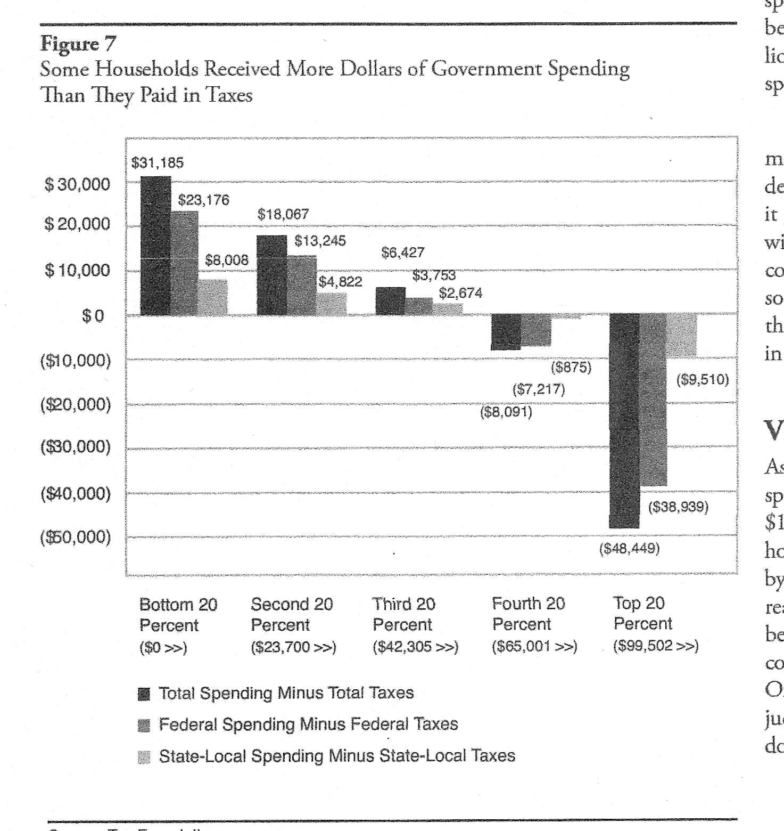
http://www.taxfoundation.org/files/sr151.pdf
i.e. 60% of the people plus 500,000+ government employees are living off the other 40%
- Then it will be 70% living off 30%
- Then 80% living off 20%
- Then 90% living off 10%
- ad infinitum
- not unlike unconstitutional private property taxes
- not unlike unconstitutional social "security" taxes
- not unlike unconstitutional taxes on wages
- not unlike unconstitutional taxes on your private property at death
- not unlike welfare, medicare, et al

17. "Our tax system is based upon voluntary assessment and payment, not upon distraint"
The Supreme Court, Flora v. U.S., 362 US145, pg. 176
- "Until the emergence of the democratic state, governments were expected to live off their own assets, supplemented by customs, excise receipts and a variety of dues.
- Direct taxes like the French taille or the Russian soul tax, were imposed only on the lower classes, i.e. the poorest elements and regarded as a mark of inferior social status.
- The affluent were asked for money only in national emergencies, ..i.e. war
- Hence, over the centuries direct taxes, when required, were treated as voluntary aids.
- In England, direct taxes were viewed as gifts..
- This attitude prevailed also in colonial America.
- In early modern France, taxes voted by the provincial estates were deemed free gifts (dons gratuits)
- In ancient Athens, taxes were considered a hallmark of tyranny; Athenian citizens were exempt from them.
- The city-state financed itself from incomes of public properties, silver mines, court fees, indirect levies, sales tax, harbor tax
- In emergencies Athenians donated money for the city's defense according to their ability
- Historical evidence thus indicates that, as a rule, in the Western world since classical antiquity and until the twentieth century, regular (as distinct from emergency) direct taxations was regarded as unlawful except for subject peoples; when imposed it carried the stigma of social inferiority.
- Governments were expected in peace time to be self supporting.
- Direct taxes were mainly resorted to in times of war. When such levies were required, they had to be approved by those who paid them... These were seen not as something the government was entitled to BUT AS GIFTS.
- Doubts have been raised as to the moral justification of the very principle of taxation. ..
- Another scholar declares the power to tax to be nothing but a form of eminent domain without compensation and therefore confiscation without cause.
- Richard Epstein concurs; "With a tax, the government takes property in the narrowest sense of the term, ending up with ownership and possession of that which was once in private hands.
- Taxation is prima facie a taking of private property
- The American Revolution was carried out for the protection of property.."
- Above quoted from "Property and Freedom", pgs. 236-239, Richard Pipes, Baird Research Professor of History Harvard University
- "Income" taxes are voluntary, i.e. there is no law that says you have to file or pay. - search the key words and verify it yourself
- "The IRS' primary task is to collect taxes under a voluntary compliance system."- Jerome Kurtz
Internal Revenue Annual Report, 1980
- "Our tax system is based on individual self-assessment and voluntary compliance." - Mortimer Caplin
Internal Revenue Audit Manual, 1975
- "No one is bound to obey an unconstitutional law and no courts are bound to enforce it. " - Sixteenth American Jurisprudence, Second Edition, Section 256.

18. The three branches of government at the state & federal levels plus some 500,000+ government employees have perverted & ignored the spirit & intent of the U.S. Constitution and the basic laws of the land.
- "The U.S. Supreme Court has stated that "No state legislator or executive or judicial officer can war against the Constitution without violating his undertaking to support it.". Cooper v. Aaron, 358 U.S. 1, 78 S.Ct. 1401 (1958).
- If a judge does not fully comply with the Constitution, then his orders are void, In re Sawyer, 124 U.S. 200 (1888), he/she is without jurisdiction, and he/she has engaged in an act or acts of treason"
- Here is another list of judges committing the highest crimes against us, i.e. treason
- http://caught.net/caught/crime.htm
- Rural property owners have two more judges for this list from the District & Superior Court of Pierce County Washington
- In Illinois, a judge must take a second oath of office. Under 705 ILCS 35/2 states, in part, that "The several judges of the circuit courts of this State, before entering upon the duties of their office, shall take and subscribe the following oath or affirmation, which shall be filed in the office of the Secretary of State:
- 'I do solemnly swear (or affirm, as the case may be) that I will support the constitution of the United States, and the constitution of the State of Illinois, and that I will faithfully discharge the duties of judge of ______ court, according to the best of my ability.'"
- Further, if the judge had enlisted in the U.S. military, then he has taken a third oath. Under Title 10 U.S.C. Section 502 the judge had subscribed to a lifetime oath, in pertinent part, as follows:

"I, __________, do solemnly swear (or affirm) that I will support and defend the Constitution of the United States against all enemies, foreign or domestic; that I will bear true faith and allegiance to the same; ...".
- Government servants must be required to swear an oath of allegiance to the U.S. Constitution before employment.
- "Counsel decided at the age of 13 to become a lawyer when he heard a story from a Jewish jeweler, who had been a lawyer in Germany in the 1930’s. He told Counsel that the way that the National Socialist Party (the Nazis) gained power in Germany was to: 1) change the laws, 2) replace the judges who opposed them, 3) remove Jewish lawyers and 4) remove all other lawyer who opposed them. It was a story he has never forgotten and it has guided his opposition to the corporate/government monopoly that now exists in the America." http://www.paynoincometax.com/pdf/101307_answer_to_order_to_show_cause.pdf
- Does this sound familiar? American government along with its political parties have corrupted our individual sovereignty beyond what 99.9% of Americans can imagine.

19. The U.S. Constitution allows for only two types of taxes
- Each state must follow the U.S. Constitution and ..
- The spirit of the Framers and the era it was written
- The first legitimate constitutional tax is "indirect" and may be enforced
- It must be applied uniformly
- e.g. imposts (e.g. a custom duty), duties (import or export tax), excises (an inland tax or duty on commodities)
- while this tax is collected by business it is ultimately passed onto the consumer
- who then pays by free choice of purchasing the goods or services or not
- The second legitimate constitutional tax is "direct" meaning;
- It must to be apportioned evenly among the states by population
- It is to be applied in emergency only
- It is to be 1/4% to 2% maximum (The Great Income Tax Hoax, pg 37)
- 2% was considered to heavy (Ibid)
- Direct taxes are VOLUNTARY (See #17 above)
- The colonies did not want any direct tax, they ran and revolted from this tyranny .
- They were well aware of the unfolding tyranny resulting from unbridled force of a FORCED DIRECT TAX.
- This "direct tax" was a compromise, i.e. they allowed it but it was VOLUNTARY .
- The intent of the Founders was to keep the government the servant & prevent it from becoming the master.
- Government could not be restrained with FORCED DIRECT TAX.
- The SPIRIT of the leading colonialists can be found in the Declaration of Independence.
- This SPIRIT became the BODY of the laws of our land through our Constitution.
- The Founding Fathers Would Not impose the same Forced Direct Tax on themselves, they revolted from.

20. The key to understanding our freedoms & taxes is in the INTENT & SPIRIT leading to the American Revolution
- The substance of this SPIRIT was in those who rebelled & revolted from the British imposed FORCED TAXES
- One third of the colonists wanted freedom from British FORCED TAX TYRANNY over the preceding 100 years
- The second one third, did not share in this spirit
- These Loyalist/Tories tried to subvert the uprising, i.e. they wanted their "security" under King George III
- The remaining one third, waffled depending on who was winning in the moment& their own self interest
- "The chief opposition for independence came mostly from Pennsylvania, New York and South Carolina.
- As Thomas Jefferson said, they "were not yet matured for falling from the parent stem." http://thedeclarationofindependence.org/
- Only 1% fought and died for those 30% who wanted to free themselves from FORCED TAX TYRANNY
- Of that 1%, only ONE man was entirely responsible for our freedom, i.e. General George Washington.
- Even congress uprooted & did not support General Washington & the troops consistently (sound familiar?)
- General Washington & the remaining 2,000 rag tag rebels were left to starve & freeze to death by Congress!
- George Washington was betrayed numerous times
- The war started in 1763 and ended in 1783
- 21 years + 94 battles + 62 troop movements + 33 Acts of British Parliament (sound familiar?)
- The American Revolution took an estimated 25,000 American lives
- 1% of the population died for the some 30% wanting freedoms, equivalent to 3 million today
- It was the most costly war in American history except for the Civil War.
- All the freedoms won from this long battle were quickly lost to the dark side, e.g. Congress
- Our current form of government is broken, tyrannical & enslaving compared to the Framers intent
- We The People do not have a legitimate government in any sense of the meaning
- Free Choice is the key to stopping tyranny, the Founding Fathers knew this secret
- We must connect all the illegitimate dots of taking ASAP to return to freedom
- Politics and politicians are a dirty business and a dirty word, they live by taking from A and giving to B
- 99.9% of Americans are confused on these truths
- It goes against all the laws of the land to take by FORCE
- Now the majority are controlled by the minority & government is upside down and backwards
- The irony is, a "majority" & "minority", without individual free choice & sovereignty, ARE TYRANNICAL
- "Something has to die in order for us to begin to know our truths", Adrienne Rich
- What has to die is the use of force & tyranny in America by any government or non government groups

______________________________________________________________________________________________________________________________

Ebenezer Ebenezer Ebenezer
The "Spirit of Christmas Past"... must be relived
The "Sprit of Christmas Present" ....must be seen with new eyes
The "Spirit of Christmas Yet To Come"...can be changed
"Answer me, Spirit, ghost of the Future!
I fear you more than any spectre I've seen.
Yet I know your purpose ......
and as I hope to live to be another man from what I was, lead on.
Lead on! The night's waning fast, and time's precious."
A Christmas Carol by Charles Dickens; Scrooge talking to the Ghost of Christmas Yet to Come.

John R.Venrick
Rural King Communist County
Socialist State of Washington
Enumclaw, WA

"Security is mostly superstition.
It does not exist in nature, nor do
the children of humans as a whole experience it.
Avoiding danger is no safer in the long run than outright exposure.
Life is either a daring adventure or nothing." Helen Keller

P.S. on Force vs. Free Choice
  - No force on earth can hold down long, individual free choice.
  - The vessel of government and ignorance cannot long hold the "steam" of individual free spirit
  - No corrupt legislation, judication or administration cannot long, hold individual natural, inalienable and constitutional rights
  - Even genocidal dictators, have not long been able to oppress individual freedom
  - Without individual free choice and individual sovereignty there is no light, i.e. freedom and liberty
  - Thus we see the greatest pall of darkness & taking enveloping America, e.g. income/wealth redistribution.
  - True freedom can only come with total free choice within the original SPIRIT of the American Revolution AND ..
  - The resulting BODY of the Constitution AND ..
  - The natural laws, natural rights AND inalienable rights of every man, women and child in the America
  - Most if not all legislation, laws, executive obfuscations are null and void as they "war against the constitution" AND our natural rights
  - "That whenever any Form of Government becomes destructive of these ends it is the Right of the People to alter or to abolish it, and to institute new Government, laying its foundation on such principles and organizing its powers in such form, as to them shall seem most likely to effect their Safety and Happiness." Declaration of Independence, July 4, 1776, para. 2.
  - Read the Declaration of Independence again, the American government has become more tyrannical than King George III.
  - All government and non government taking of our inalienable rights must be resisted
  - We The People no longer have a federal democratic republic, we have a tyrannical centralized "democracy" controlled by foreigners
  - Freedom in American has come to be only in form only, without the substance, the SPIRIT or the BODY.
  - Freedom has been consumed for power, money, careers, ignorance, social welfare, foreign loans, interest
  - Most of all - freedom has been taken by the inability of most people to honor and respect the significance of individual suffering
  - Individual suffering is the seed for change, i.e. most of us have to be on our knees and lips to even consider change
  - Only you can change yourself, this is no business of government. The Founding Fathers knew this well.
  - The Framers did not give the government the power to become the state nanny
  - Charity comes from the heart of "man" NOT FROM TAX TYRANNY
  - Charity comes from freely given love and compassion from one free person to another without FORCED TYRANNICAL TAXES
  - Government has become a vampire sucking the blood from the healthy TO SERVE ITSELF & THOSE WHO CONTROL IT
  - This is why the Founding Fathers, well knew the meaning of FREE CHOICE, individual consent & unalienable rights.
  - "Our constitution does not profess to have been established simply by the majority; but by "the people"; the minority, as much as the majority." Lysander Spooner, "No Treason", 1867
  - American Government, its political parties & all those groups who prey off of the freedom of others usurp the free will & free choice of We The Sovereign.

